**IDEATION PHASE**

**BRAINSTORM TEMPLATES**

|  |  |
| --- | --- |
| DATE | 18 JUNE 2005 |
| TEAM ID | LTVIP2025TMID52211 |
| PROJECT NAME | COSMETIC INSIGHTS:NAVIGATING COSMETICS TREND AND CONSUMER INSIGHTS WITH TABLEAU |
| MAXIMUM MARKS | 4 MARKS |

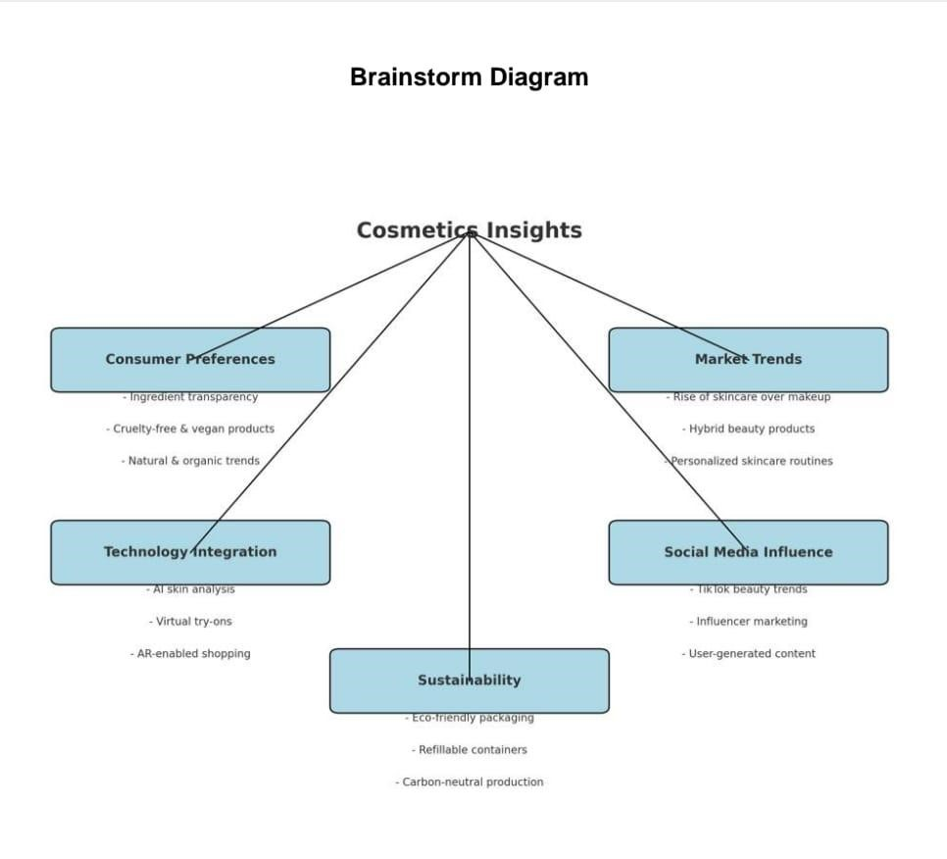

**Phase 1: Define Objectives**

* Focus on product innovation, marketing, or sustainability?
* Who is your target audience?

**Phase 2: Conduct Market Scanning**

Gather global and local market data.

* Track leading brands and product categories.

**Phase 3: Customer-Centric Insights**

* Identify key emotional or functional product drivers

**Phase 4: Analyze Digital & Social Influence**

Use social media analytics.

**Phase 5: Technology & Innovation Mapping**

Explore how technology is transforming cosmetics.

* Smart skincare devices and diagnostics.